Applications of Polynomial Long Division Worksheet: Use polynomial long division and the definition of a factor to solve the following problems. Show all steps!

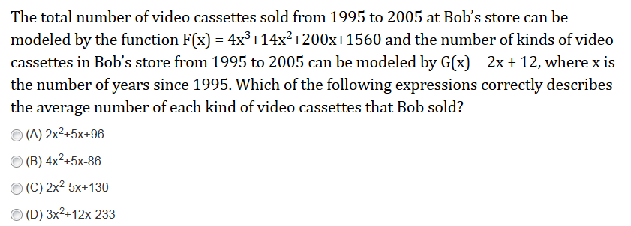
1.

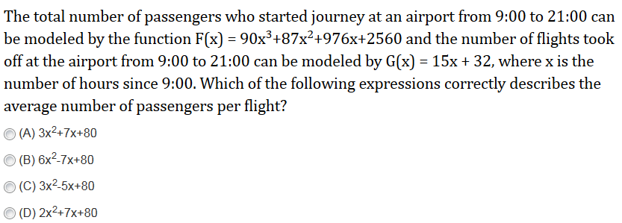
2.

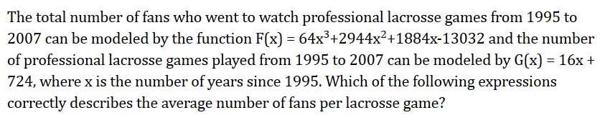
3.

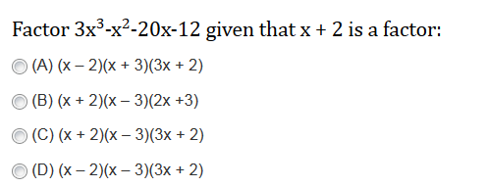
4.

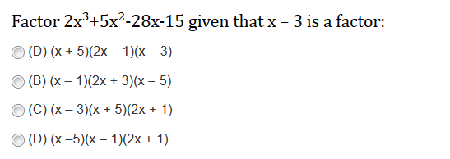
5.

6. The volume of a rectangular box is 12x³ – 19x² – 13x + 6. Given the height of the box is (x – 2), find a polynomial expression for the length and width.

7. An aquarium whose volume is V = 10x³ + 43x² – 47x – 60 cubic inches has a width of (x + 5) inches. Find a polynomial expression for the length and width of the aquarium.

8. The volume of a carton is given to be V = 6x³-35x²-41x+210. If the height of the carton is given to be x – 6, what is the area of the rectangular base of the carton?

9. Find a value for c that makes (x + 5) a factor of the polynomial 10x³+43x²-47x + c .

