Name:___________________________________________ Date: ______________________

**Complete the following table using each polynomial function:**

|  |  |  |  |
| --- | --- | --- | --- |
| **Function** | **Degree** | **End Behavior** | **Domain** |
|  |  | As  As |  |
|  |  | As  As |  |
|  |  | As  As |  |
|  |  | As  As |  |
|  |  | As  As |  |

**Use the equations to answer the following:**

|  |  |  |
| --- | --- | --- |
| **Function** | **Degree** | **Max # of Extrema** |
|  |  |  |
|  |  |  |
|  |  |  |
|  |  |  |
|  |  |  |

**Determine the end behavior and maximum number of extrema (u-turns) w/o calculator:**

|  |  |
| --- | --- |
|  |  |
|  |  |

**Find the number of zeros, y-int, & end behavior. Sketch the graph:**

|  |  |
| --- | --- |
| # of Zeros: __________ Y-Int: _____________ | # of Zeros: ________ Y-Int: _____________ |

**Answer all of the following questions for the following graph:**

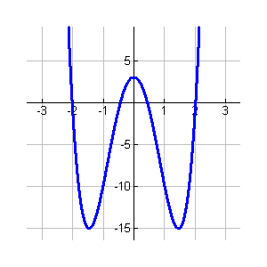

(0, 3)

(1.5, -15)

(-1.5, -15)

|  |  |
| --- | --- |
| Domain: | Range: |
| Increasing: | Decreasing: |
| x-intercepts: | y-intercept: |
| Abs. Max: | Abs. Min: |
| Rel. Max: | Rel. Min: |
| Min. degree | Sign of leading Coeff. |