Resolving Vectors
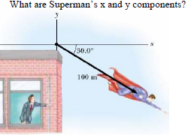
1.

2. What are the x and y components of the plane’s velocity?
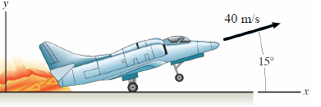

3. How fast and at what angle is the plane traveling?

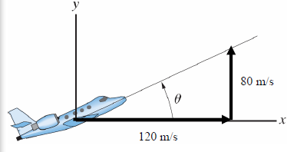

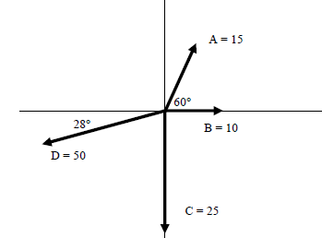
4. What is the resultant vector for the following forces? (The table may help)

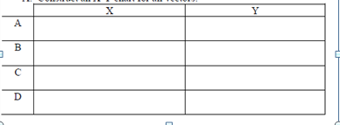

5. Determine the resultant of the following

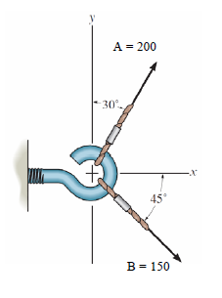

6. Determine the resultant of the following

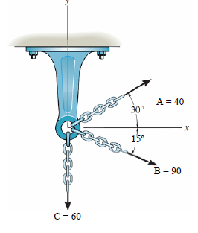

7. How far east has a person walked if he travels 350 m in a direction of 25º E of N?

8. What would be the resulting displacement and direction if a snail crawls 2.0 m north then 3.0 m east?
9. A seagull flying with an airspeed of 10 km/hr is flying north but suddenly encounters a wind of 5 km/h at 340º. What will be the new direction and airspeed of the seagull?

10. A boat crosses a river at 10.5 knots at a bearing of 23º of N of E. If the current in the river is 3.7 knots at 8º E of S. What is the new speed and bearing?

11. Two boys push on a box. One pushes with a force of 125 N to the east. The other exerts a force of 165 N to the north. What is the size and direction of the resultant force on the box?

12. Three people are pulling on a tree. The first person pulls with 15 N at 65º, the second with 16 N at 135º and third with 11 N at 195º. What is the magnitude and direction of the resultant force on the tree?

