**Graph and fill in all critical parts for each ellipse and circle.**

1. 

vertical or horizontal ellipse

Center: ____________ a = ____________

b = ____________ c = ____________

Length of Major Axis: ____________

Length of Minor Axis: ____________

Vertices: ____________

Co-vertices: ____________

Foci: ____________ e = ____________

Horizontal Axis ____________________

Vertical Axis ____________________

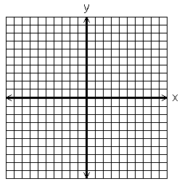

2. 9(x + 1) 2 + 4(y – 2) 2 = 144

vertical or horizontal ellipse

Center: ____________ a = ____________

b = ____________ c = ____________

Length of Major Axis: ____________

Length of Minor Axis: ____________

Vertices: ____________

Co-vertices: ____________

Foci: ____________ e = ____________

Horizontal Axis ____________________

Vertical Axis ____________________



**Write the equations for the following ellipses using the given information.**

3. Vertices at (-7, 3) and (3, 3) and

co-vertices at (-2, 0) and (-2, 6)

_________________________

4. Vertices at (5, 1) and (5, 9) and

foci at (5, 2) and (5, 8)

_________________________

5. Foci at (-6, 2) and (4, 2) and length of the minor axis is 8.

_________________________

6. (x – 2) 2 + y 2 = 9

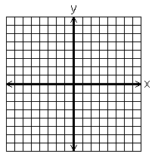Center: ____________ Radius = ______________

**Write equations of the following circles using the given information.**

7. Center at the origin

radius = 3

_________________________

8. Center: (-2, 5)

radius = 4

_________________________

9. Center: (-4, -5) and

passes through the point (0, -2)

_________________________

10. Endpoints of the diameter are at

(-2, 5) and (6, 1)

_________________________