Review for functions quiz:

Are the following functions? (yes, no) If so, are they one to one? (yes, no)

1.

2. 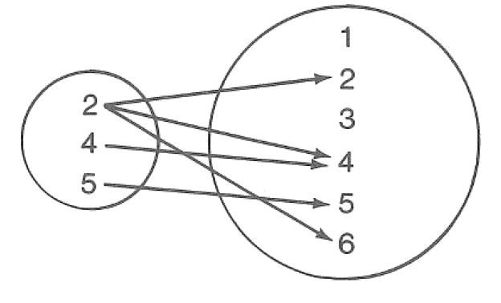

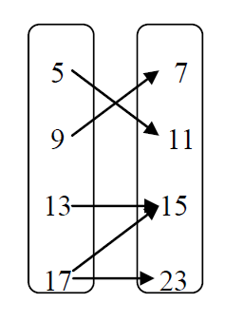

3.

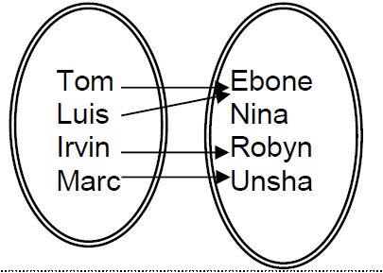

4.  5. 

6. 7.

 

8.



Consider the function 

9.  10.  11. 

Given  and  and 

12.  13. 

14.  15. 

16.  17. 

18. Find the inverse of  (don’t forget to use correct notation)

19. Are the functions inverses of each other? Verify your answer.

  and 