Extra Practice with Graphs of Rational Functions

|  |  |  |  |  |
| --- | --- | --- | --- | --- |
| Function | Vertical Asymptote | Domain | x-intercept (solve the equation by letting  y = 0) | y-intercept (let x = 0) |
| 1. |  |  |  |  |
| Horizontal Asymptote | Range |
|  |  |

|  |  |  |  |  |
| --- | --- | --- | --- | --- |
| Function | Vertical Asymptote | Domain | x-intercept (solve the equation by letting  y = 0) | y-intercept (let x = 0) |
| 2. |  |  |  |  |
| Horizontal Asymptote | Range |
|  |  |

|  |  |  |  |  |
| --- | --- | --- | --- | --- |
| Function | Vertical Asymptote | Domain | x-intercept (solve the equation by letting  y = 0) | y-intercept (let x = 0) |
| 3. |  |  |  |  |
| Horizontal Asymptote | Range |
|  |  |

|  |  |  |  |  |
| --- | --- | --- | --- | --- |
| Function | Vertical Asymptote | Domain | x-intercept (solve the equation by letting  y = 0) | y-intercept (let x = 0) |
| 4. |  |  |  |  |
| Horizontal Asymptote | Range |
|  |  |

1. 2.

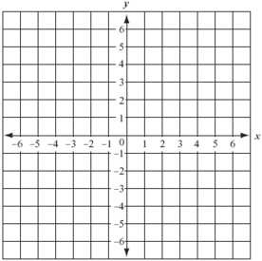 

3. 4.

 