Applications of Determinants Name _________________________

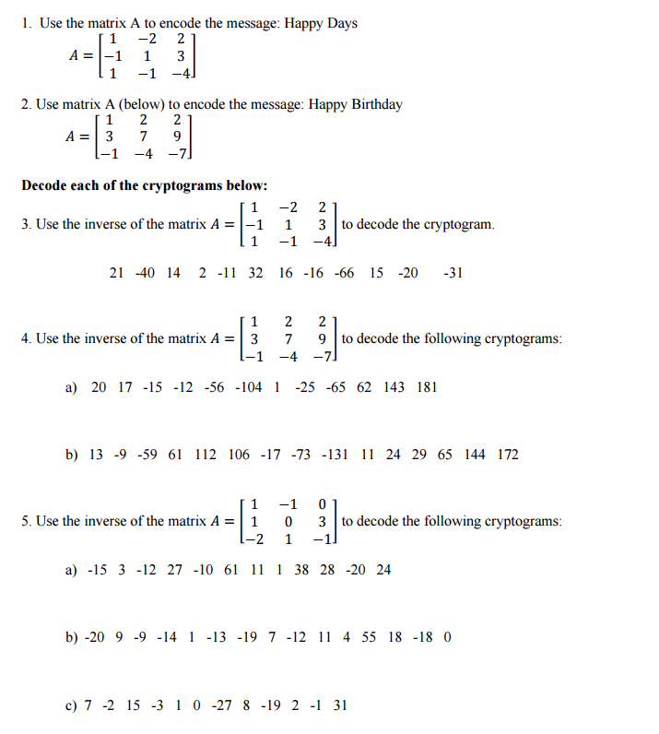
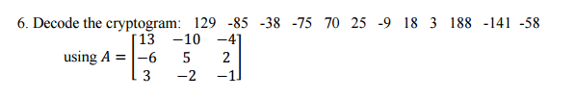

- Are the points (-4, 10), (0, 8), and (-20, 21) collinear?

- Find the equation of the line through (4,5) and (-2, 6)

- Are the points (-6, 10) (2,5) and (-4, -7) collinear?

- Find the equation of line through (-5, -9) and (0,6)

- Find the area of the triangle whose vertices are (-4,1) (3,2) and (4,6)

- Find the area of the triangle whose vertices are (4,-5) (3,-8), and (-1,3)

- A surveying crew located three points on a map whose vertices formed a triangular area. A coordinate grid in which one unit equals 10 miles is laid over the map so that the vertices are located at (0,-1), (-2,-6) and (3,-2). Use a determinant to find the area of the triangle.

