Algebra 2 Quiz Review Rationals: Complex Fractions, Solving Rational Equations, Graphing Rationals

Name_________________________________________

DO THIS ON YOUR OWN PAPER!

Simplify the complex fraction:

1.  2.  3. 

Solve the Rational equation. List the excluded values:

4.  5. 

6. 

State the horizontal asymptote ( if any):

7.  8.  9. 

State the required information and sketch the graph:

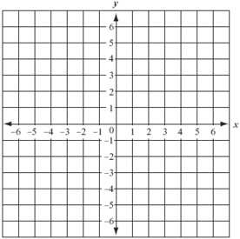10. 

|  |  |  |  |
| --- | --- | --- | --- |
| Vertical  asymptote | Horizontal asymptote | x-intercept  (exact value) | y-intercept  (exact value) |
|  |  |  |  |
| Domain | Range |
|  |  |

11. 



|  |  |  |  |
| --- | --- | --- | --- |
| Vertical  asymptote | Horizontal asymptote | x-intercept  (exact value) | y-intercept  (exact value) |
|  |  |  |  |
| Domain | Range |
|  |  |