Extra practice on parabolas

Give the direction, vertex, p, focus, directrix, and graph

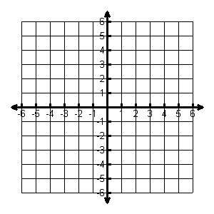

1. 



2. 



3. 



4. 

Put into standard form. Then do all the stuff from 1st page.



5. 

6. 

**Use the information to write the equation of the parabola**

7. Vertex (9,1), Focus (8,1)

8. Vertex (-4,3) Focus (-5,3)

9. Vertex (9,0) Directrix x = 7

10. Vertex (-3,3) Directrix x = 1

11. Focus (4,2) Directrix y=6

12. Focus (3,2) Directrix y = 0