Parabolas and Hyperbolas Practice Name ___________________________

Date ___________________

**Directions: Circle the name that correctly identifies what type of conic each equation represents.**

1.  Circle Ellipse Hyperbola Parabola

1.  Circle Ellipse Hyperbola Parabola

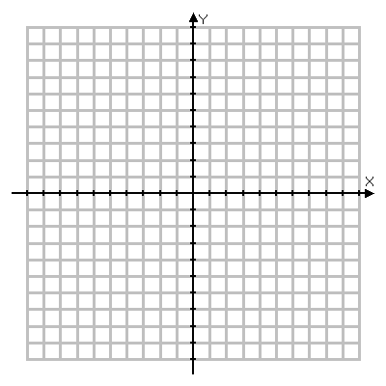**Graph the following. Then identify the vertex, focus, and directrix.**

1. 

Vertex: ___________

Focus: ___________

Directrix: ___________

**Write the equation of the parabola in standard form given the following information.**

1. Vertex (9, 7) Directrix 

**Complete the square to put the following parabolas into standard form.**

1. 

**Graph the following. Then identify the center, vertices, and foci for each.**

1. 

Center: ________

Vertices: ________ ________

Foci: ________ ________

**Write the equation of the hyperbola in standard form given the following information.**

1. Vertices (9, 7), (9, -17) 

Foci (9, 8), (9, -18)

**Complete the square to put the following hyperbolas into standard form.**

1. 