Midterm Review #2 Pre-Calculus

1. To approximate the [length](javascript:def('/Glossary/glossaryterm.aspx?word=Length',%20500,%20500);) of a lake, a surveyor starts at one end of the lake and walks 245 yards. He then turns 110º and walks 270 yards until he arrives at the other end of the lake. Approximately how long is the lake?

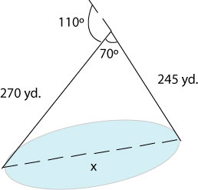

1. Graph the equation: .
2. Determine the number of triangles possible for:

a) 

b) 

c) 

1. Find the exact value of tan (67.5o) by using a half angle identity.
2. Find the exact value of cot 2100
3. Find the phase shift of 
4. Find solutions that satisfy the equation 
5. What is the reference angle for 289o?
6. What is the value of?
7. What is the solution to?
8. Find the exact value of sin, cos, and tan if 
9. Find the value of 
10. What is the amplitude of?
11. Find the area of the triangle with B=69o, c= 26 ft, a = 21 ft.
12. Find all values that satisfy the equation 
13. Graph  over one period
14. Given that (-6, 10) is a point on the terminal side of  , an angle in standard position, find the exact value of  .
15. If C = 75o, B =65 o, b = 200 in, find c.
16. Simplify 
17. What is the least positive angle that is co-terminal with -515˚?
18. What is the period of?
19. What is the exact value of cos (-105˚)? (Hint: Use the half angle formula)
20. What is the value of in degrees?
21. If a = 129, c = 144, b = 136, find C.
22. What is the simplest form of?