Review Rational Functions Test: Name___________________________________________

DO THIS ON YOUR OWN PAPER

1. Find the Quotient: 

2. Simplify completely: 

3. Simplify: 

4. Solve: 

5. What is/are the solutions of the equation? 

6. Which equation has the graph shown?

a.  b.  c.  d. 

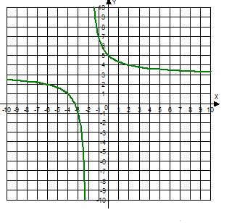

7. Simplify the expression: 

8. What is the lowest common denominator of  ?

9. Use the graph provided to help analyze the function: 

|  |  |  |  |
| --- | --- | --- | --- |
| Vertical Asymptote | Domain | x-intercept (solve the equation by letting  y = 0) | y-intercept (let x = 0) |
|  |  |  |  |
| Horizontal Asymptote | Range |
|  |  |

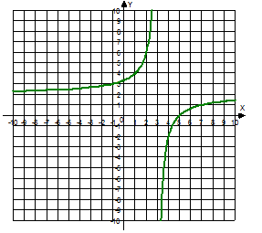

10. Identify all the vertical and horizontal asymptotes of each function:

   

   

11. Sketch a graph of the function 

|  |  |  |
| --- | --- | --- |
| Vertical Asymptote | x-intercept (solve the equation by letting  y = 0) | y-intercept (let x = 0) |
|  |  |  |
| Horizontal Asymptote |
|  |

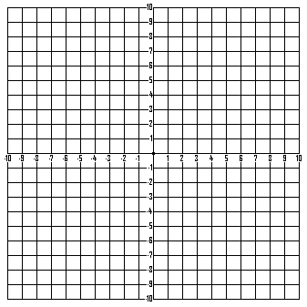

Perform the indicated operations:

12.  13.  14.  15. 

16.  17. 

List the excluded values and solve. Watch for extraneous solutions.

18.  19.  20. 

21.  22. 