Review for Polynomial Test 3

Name__________________________________________ Questions 1-6



(2.5, 2.5)

1. How many extrema does this function have?

2. What is the least possible degree of the function?

3. Which of the following statements is FALSE for the function shown?

a. The domain is $\left(-∞, ∞\right)$.

(4, -5.5)

b. The function has zeros at -1, 1.7, 3, 5.

c. The function is even and has symmetry about the y axis.

(0, -9)

d. The function has no maximum.

4. Describe the leading coefficient of the function.

5. What is the range of the function?

6. What is the end behavior of the function?

A.  C. 

B.  D. 

7. For the polynomial , find the average rate of change on the interval 

8. What is the solution set in interval notation for: 

9. Which one of these functions is odd?

a.  b.  c.  d. 

10.

|  |  |
| --- | --- |
| a. Domain |  |
| b. Range |  |
| c. Zeros |  |
| d. y-intercept |  |
| e. # extrema |  |
| f. degree of the polynomial |  |
| g. Is there an absolute extrema? |  |
| h. Interval(s) of Increase |  |
| i. Interval(s) of Decrease |  |
| j. End behavior: |  |

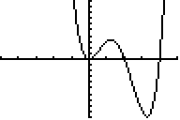

(2.5,3.5)

(3,-10)

11.

|  |  |
| --- | --- |
| a. Domain |  |
| b. Range |  |
| c. Zeros |  |
| d. y-intercept |  |
| e. # extrema |  |
| f. degree of the polynomial |  |
| g. Is there an absolute extrema? |  |
| h. Interval(s) of Increase |  |
| i. Interval(s) of Decrease |  |
| j. End behavior: |  |

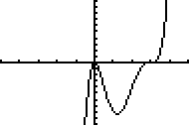

(2.5,-8.5)

12. Determine whether each of the given functions is *odd*, *even* or neither. Write O, E or N

|  |  |  |  |  |
| --- | --- | --- | --- | --- |
| [image]  _________ | _________ | _________ | _________ | _________ |
| [image]  _________ | _________ | _________ | _________ | [image]  _________ |

Sketch the graph of the polynomial with the given information.

13.  14.  with zeros at -3,-2,2

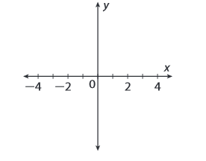

15. 

16.



The degree is odd, the leading coefficient is negative, and there are zeros at -2, 0, 2 and 4 with a multiplicity of 2

Solve the polynomial inequalities. Write the solution set in interval notation.

17. 

18. 

19. 

20. Draw the number line solution of:  *This is multiple choice on the test.

21. The table of values below represents a cubic function. Find the average rate of change on the function over the following intervals. Show you work.

a.  b.  c. 

|  |  |
| --- | --- |
| x | Y |
| -9 | -432 |
| -8 | -275 |
| -7 | -160 |
| -6 | -81 |
| -5 | -32 |
| -4 | -7 |
| -3 | 0 |
| -2 | -5 |
| -1 | -16 |
| 0 | -27 |
| 1 | -32 |
| 2 | -25 |
| 3 | 0 |
| 4 | 49 |
| 5 | 128 |
| 6 | 243 |
| 7 | 400 |