Find all zeros:
1: Solve (x + 3)(x – 5) = 0 2: (2x + 1)(6x – 7) = 0

3: 4x(x + 6) = 0 4: 9x² – 25 = 0

5: x² + 7x + 10 = 0 6: 3x² – 12 = 0

7. 8.
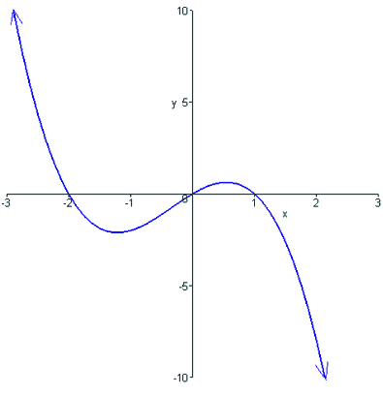
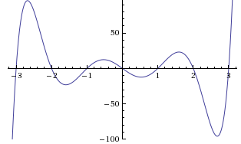

9. 10.
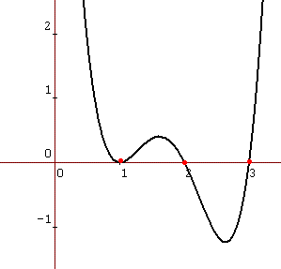
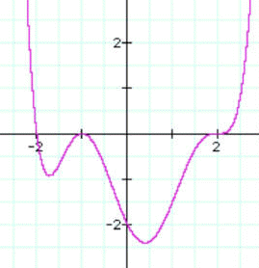

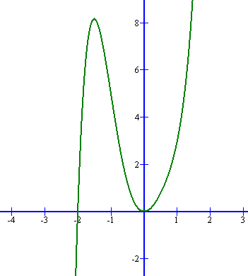
11.

