Algebra II Graphing Radical Functions Worksheet II

Graph the following radical functions equations. List the ***Domain and Range*** in interval notation.

1.  2. 

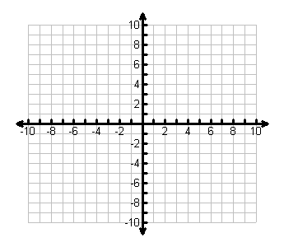

3.  4. 





5.  6. 

