Name: __________________________________ Per: __________ Date: __________________

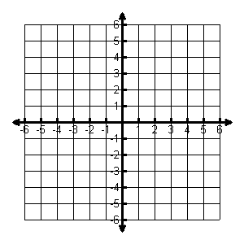**Graph the following circles. State the center and radius.**

1. 

Center: _______

Radius: ______

1. 

Center: _________

Radius: ________

1. 

Center: _______

Radius: ______

1. 

Center: _________

Radius: ________

1. 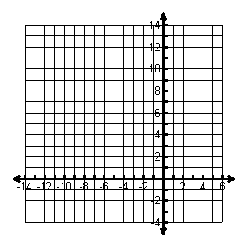

Center: _______

Radius: ______

1. 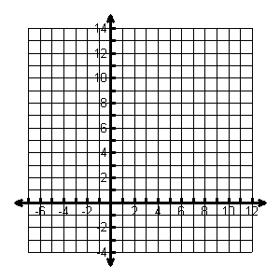

Center: _________

Radius: ________

**Write the equation of the circle in standard form. Then, convert to the general form.**

7. 8.

**Find the equation of the circle given the following information**

9.Radius 2, center (-1,-4)

10.Center (2,0) Point (5,4)

11.Diam. endpts (-2,4) (4,2)

**Write the standard equation for the circle. State the center and radius.**

1. 
2. 
3. 
4. 
5. 
6. 