How Can I Use the Graph of a Polynomial to Factor and Solve the Function?
First of all, it’s very important to remember that the _____________________ of the graph are the ___________________ of the function. These will also be referred to as _____________ or _______________. They all mean the same thing!

Secondly, you must learn and apply the Zero Product Property which states
If a·b = 0, then a = 0 or b = 0
EX 1: Solve (x + 3)(x – 5) = 0 EX 2: (2x + 1)(6x – 7) = 0

EX 3: 4x(x + 6) = 0 EX 4: 9x² – 25 = 0

EX 5: x² + 7x + 10 = 0 EX 6: 3x² – 12 = 0

Let’s see what role the graph of the polynomial plays. . .
EX 1 EX 2
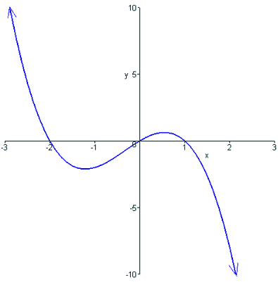
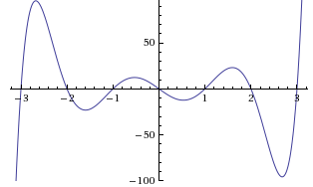

EX 3 EX 4
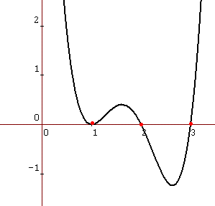
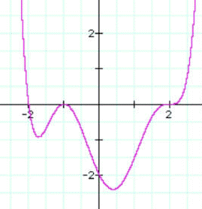

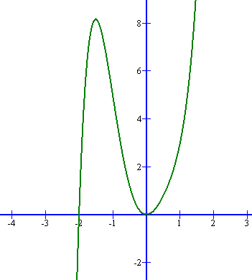
EX 5

