**Conic Sections Practice**

**Directions: Graph the following conic sections and list the characteristics that are specific to that conic section. You will NOT use ALL of the blanks for any one conic section.**

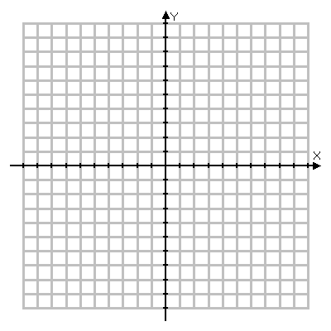1.  2. 

C E H P

C E H P

**Characteristics:**

Center/Vertex: ________

Vertices: ________ ________

Co-Vertices: ________ ________

Foci/Focus: ________ ________

Radius or Directrix: ________

**Characteristics:**

Center/Vertex: ________

Vertices: ________ ________

Co-Vertices: ________ ________

Foci/Focus: ________ ________

Radius or Directrix: ________

3.  4. 

C E H P

C E H P

**Characteristics:**

Center/Vertex: ________

Vertices: ________ ________

Co-Vertices: ________ ________

Foci/Focus: ________ ________

Radius or Directrix: ________

**Characteristics:**

Center/Vertex: ________

Vertices: ________ ________

Co-Vertices: ________ ________

Foci/Focus: ________ ________

Radius or Directrix: ________

5.  6. 

C E H P

C E H P

**Characteristics:**

Center/Vertex: ________

Vertices: ________ ________

Co-Vertices: ________ ________

Foci/Focus: ________ ________

Radius or Directrix: ________

**Characteristics:**

Center/Vertex: ________

Vertices: ________ ________

Co-Vertices: ________ ________

Foci/Focus: ________ ________

Radius or Directrix: ________

7.  8. 

C E H P

C E H P

**Characteristics:**

Center/Vertex: ________

Vertices: ________ ________

Co-Vertices: ________ ________

Foci/Focus: ________ ________

Radius or Directrix: ________

**Characteristics:**

Center/Vertex: ________

Vertices: ________ ________

Co-Vertices: ________ ________

Foci/Focus: ________ ________

Radius or Directrix: ________

Solve the following equations:

9. 

10. 

Identify the conic section, then rewrite in standard form. If it is a circle, identify the center and radius. If it is an ellipse or hyperbola, identify the center and tell whether it is horizontal or vertical. If it is a parabola, identify the vertex and tell whether the graph opens up, down, right or left.

11. x2 + y2 – 6x – 2y + 1 = 0 12. y2 – 12x – 72 = 0

13. 9x2 + 4y2 + 54x – 16y + 61 = 0 14. -25x2 + 16y2 – 150x – 96y – 481 = 0

15. 4x2 – y2 + 8x – 12 = 0 16. 2x2 + 2y2 – 8x + 4y – 2 = 0

17. 16x2 – y2 + 96x + 8y + 112 = 0 18. 

Use the information provided to write each equation in standard form

19. Circle with  20. Circle with 

21. Circle with 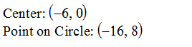 22. Ellipse with 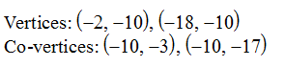

23. Ellipse with  24. Ellipse with 

25. Hyperbola with  26. Hyperbola with 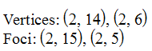

27. Parabola with 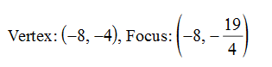 28. Parabola with 