North Cobb High School Course Syllabus
GSE Algebra 2 Y

Algebra 2 is a one-semester course which explores the relationship between functions and how they are modeled through various applications. The purpose of this class is allow students to investigate how functions are used to problem-solve and critically analyze real-world situations.
Unit 1 | Polynomial Functions
Unit 2 | Rational Functions
Unit 3 | Radical Functions
Unit 4 | Exponential Functions
Unit 5 | Logarithmic Functions

Required Materials

Students who are organized and adequately prepared for class will find the greatest chance for success. Please bring a 2” to 3” 3-ring binder, pencils and erasers, highlighter pen, loose-leaf paper, and graphing calculator or scientific calculator.

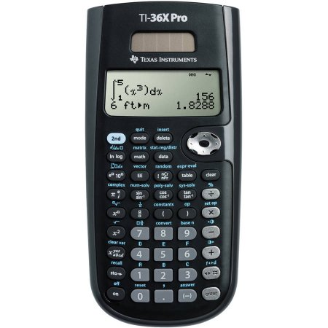
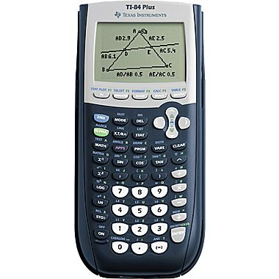
* Graphing calculators are highly recommended for this course. Proficiency with a graphing calculator is a skill that will be tremendously helpful when taking the SAT and college courses. If purchasing, please choose a TI-83, or TI-84 (base or plus model). Graphing calculators may also be checked out at NCHS. Another recommended calculator option is the TI-36X Pro.

Textbook
Holt McDougal’s Advanced Algebra, 2014 edition

Electronic Resources
Our class webpage can be accessed through the North Cobb High School home page, or directly through houstonmath.weebly.com.

Grading System

In Synergy, the class is broken into three categories - formative, summative, and cumulative tests. Formative grades comprise of homework, quizzes and daily tasks; they will be weighted at 30%. Summative assessments include tests and projects; they will weighted at 54%. Cumulative tests consist of the mid-term and final exams; they will be weighted at 16% of the overall class grade.

GSE Algebra II Y
Category | Formative | Summative | Cumulative Tests | Total
Weight | 30% | 54% | 16% | 100%

How to be successful in my class
Please come to class on time and prepared to learn. Keep up with your assignments on a timely basis. Homework should be done nightly. Do not wait until the day before the test to get help! If a student must miss class, students should make up work within two days. Make up tests will only be given before or after school.

It is standard practice in the math classroom for students to show their work! Answers alone are unacceptable. Students must be able to justify their solutions and teachers must be able to assess students’ understanding, therefore all steps (or a written explanation) must accompany each problem.

Learning math is heavily dependent on practicing skills and building cumulative knowledge.

Expectations

STAY ON TASK the entire period – no cell phones or devices unless specified by teacher, no putting your head down/sleeping, no side conversations, be engaged in learning

BE RESPECTFUL – respect people and property, no demeaning, offensive or intimidating language

BE TIDY – keep classroom tidy, including throwing away trash and food

STAY SEATED – please remain seated until you are dismissed

FOLLOW NCHS/CCSD POLICIES AND PROCEDURES – this includes but is not limited to dress code, tardies, and the code of conduct

Discipline (unless there is already a NCHS policy such as dress code and tardies)

1st offense – Warning and student/teacher conference
2nd offense – Parent contact and student/teacher conference
3rd offense – Parent contact and teacher assigned detention
4th offense – Administrative referral

Extra Help/ Tutoring
If you need extra help, I can be available by appointment.

Contact Information
Feel free to contact me anytime: Carol.houston@cobbk12.org

Please check ParentVue at least once a week for your student’s current grade and attendance report.

*Parents and students, please read and complete the parent letter attached to this syllabus.

Dear Parent(s),

Please read this syllabus carefully with your student. It is critical that you and your child clearly understand the expectations of the course. I believe that strong organizational skills, general preparedness, and a good worth ethic are key elements to achieving academic and personal success. Please help your student in acquiring the supplies needed, encouraging good study habits, and supporting their learning efforts. I am looking forward to a great semester! If you have any questions or concerns, you may contact me at Carol.Houston@Cobbk12.org.

________________________________ _____________________________________
Print Student Name Student Signature

Home Phone Number ____________________________________________________

Student Contact Information: ___________________________________________

Parent 1/Guardian Name _______________________________________________

E-mail address _______________________________________

Work Phone Number_____________________________________________________

Cell Phone Number________________________________________________________

Parent 2/Guardian Name _______________________________________________

E-mail address _______________________________________

Work Phone Number_____________________________________________________

Cell Phone Number________________________________________________________

One thing you would like me to know about your son/daughter_________________________

Parent/Guardian Signature ___________________________________________

