Polynomials Part 1 Review Name_________________________________________

**Do Everything On Your Own Paper- show your work**

1. Simplify:  __________________________________

2. Simplify:  ___________________________

3. Find the coefficient of 4th term in the binomial expansion:  _______________________________

4. The number of computer sales from 1971 to 1989 (in millions) is modeled by the expression

** The number of IPad sales from 1971 to 1989 (in millions) is modeled by the expression *y* =*0.26x + 55.32*. Find an expression that models the total number of sales, *n*, since 1991. Show all steps._________________________________

5. Write the polynomial in standard form and name the polynomial based on degree and terms:

 ___________________________ _________________ ___________________

6. Factor completely: 

___________________________________________________________________________________

**FACTOR EACH POLYNOMIAL COMPLETELY:**

8.  _______________________________________________________

9.  ________________________________________________________

10.  ______________________________________________________

11.  ___________________________________________________

12.  ________________________________________________________

13.  ________________________________________________

14.  _____________________________________________________

15.  __________________________________________________________

16. Complete Pascal’s Triangle 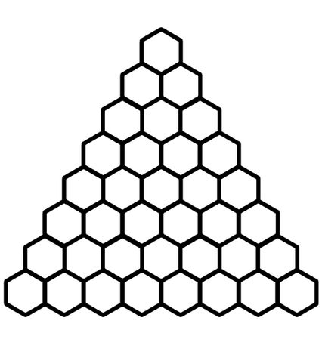

17. Find the 5th term of:  __________________________________________

18. Find the first term of:  ________________________________________

20. Expand completely:  _____________________________________________

**Find the quotient and remainder using polynomial long division:**

21.  ________________________________________

22.  __________________________________________

23. Rewrite the polynomial in standard form and identify the degree, the leading coefficient, and the constant. 

_________________________________________________________________________

24. Write a polynomial expression in standard form that represents the shaded area of the diagram. Show all steps._______________________________________________________________

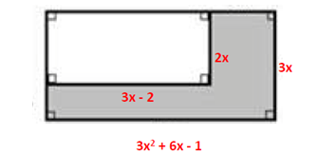

6x

5x

5x-4



25. Create: a linear monomial, a quartic binomial, a cubic binomial, quadratic trinomial