GSE Algebra 2Y Name ______________________________________ Review for the Test: Function Operations, Inverses, and Radical Equations

Choose the best answer.

_______ 1. Which set of ordered pairs does NOT represent a function?

A. {(-5,7), (7,-5), (8,-3), (-3,8)} B. {(-5,7), (8,5), (2,-8), (10,-2)}

C. {(-5,7), (2,7), (8,7), (10,7)} D. {(-5,7), (8,-3), (-3,5), (-5,-8)}

______ 2. If f(x) = -6x -5 and g(x) = x2 + 6 ,then f (g(-4)) is equal to?

_______ 3. Find the inverse of the function 

_______ 4. Solve 

______ 5. What is the solution set of the equation 

_______ 6. What is the solution of the equation  ?

_______ 7. Given f(x) = -4x - 9 and g(x) = -6x2 – 11, find f(x) – g(x)

_______ 8. What is the domain of the function  ?

_______ 9. Which of these graphs is *one - to - one*?

A. 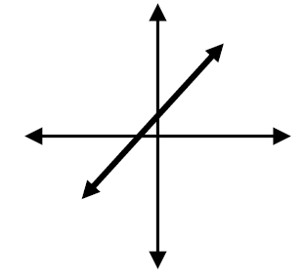 B. 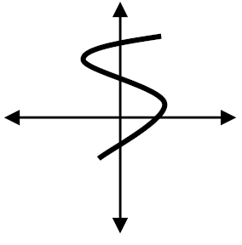 C.  D. 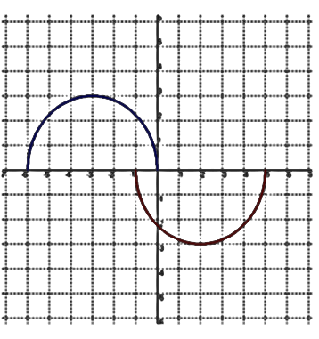

______ 10. 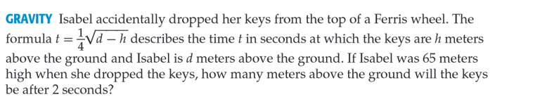

Let the functions be defined as f(x) = 6x - 18 g(x) = x2 – 9 h(x) = -3x j(x) = x – 12

Find all the following and state any domain restrictions.

11. f(x) – h(x) ________________ 12 . f(x) · j(x) _______________

13.  ________________ 14. -5h(x) + 6j(x) _______________

15. h(g(x)) _________________ 16. g(j(2)) _______________

17. j(g(x)) _________________ 18. f(g(h(j(-3)))) _______________

Find the inverse of the following functions. Show all steps.

19.  ________________ 20.  ______________

21. Use function composition to verify that f(x) = 6x + 18 and  are inverses of each other.

Solve. Check for extraneous solutions.

22.  __________ 23.  __________

24.  ___________ 25.  _________

26.  ____________ 27.  __________

Sketch a graph of each function, then identify the domain and range using interval notation.

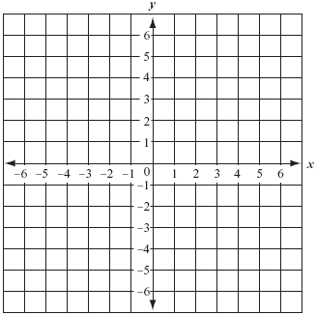28.  29. 

 Domain _________ Domain _________

Range __________ Range ___________

31. The graph of f(x) is shown below. Sketch the inverse of the graph on the same grid.



30. 

Is the inverse a function? How do you know?

Write the domain and range of the inverse relation.

D: ______________

R: ______________

Domain __________

Range __________

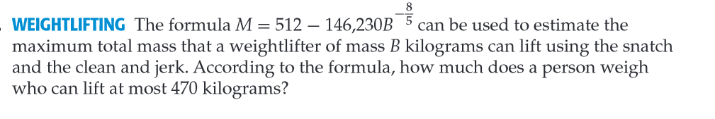

32.

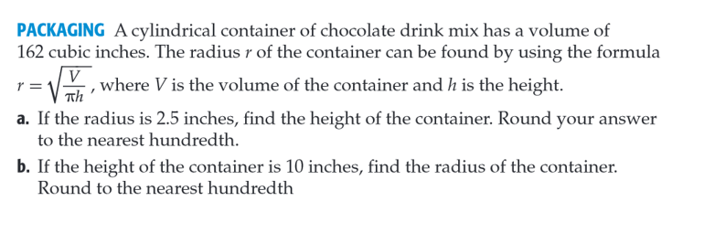

33.